Lab - Exploring FTP
Objectives
Part 1: Use FTP from a Command Prompt
Part 2: Use FTP in a Browser
Part 3: Download an FTP File Using WS_FTP LE (Optional)
Background / Scenario
The File Transfer Protocol (FTP) is part of the TCP/IP suite. FTP is used to transfer files from one network device to another network device. Windows includes an FTP client application that you can execute from the command prompt. There are also free graphical user interface (GUI) versions of FTP that you can download. The GUI versions are easier to use than typing from a command prompt. FTP is frequently used for the transfer of files that may be too large to send using email.
When using FTP, one computer is normally the server and the other computer is the client. When accessing the server from the client, you need to provide a username and password. Some FTP servers have a user named anonymous. You can access these types of sites by simply typing “anonymous” for the user, without a password. Usually, the site administrator has files that can be copied but does not allow files to be posted with the anonymous user. Furthermore, FTP is not a secure protocol because the data is not encrypted during transmission.
In this lab, you will learn how to use anonymous FTP from the Windows command-line C:\> prompt. You will access an anonymous FTP server using your browser. Finally, you will use the GUI-based FTP program, WS_FTP LE.
Required Resources
1 PC (Windows 7 or 8 with access to the command prompt, Internet access, and WS_FTP LE installed (optional))
- Use FTP from a Command Prompt
    - Click the Windows Start button, type cmd in the search field, and press Enter to open a command window.
    - At the C:\> prompt type ftp ftp.cdc.gov. At the prompt that says User (ftp.cdc.gov:(none)): type anonymous. For the password, do not type anything. Press Enter to be logged in as an anonymous user.
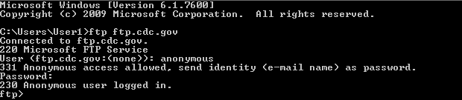

Notice that the C:\> prompt has been replaced with the ftp> prompt. Type ls to list the files and directories. At the time that this lab was authored, there was a Readme file.
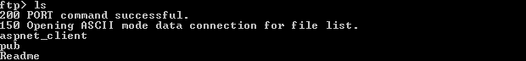
    - At the prompt, type get Readme. This downloads the file to your local computer from the anonymous FTP server the Center for Disease Control has setup. The file will be copied into the directory shown in the C:\> prompt (C:\Users\User1 in this case).
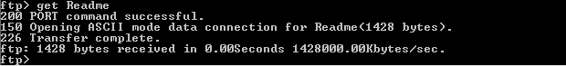
    - Type quit to leave FTP and return to the C:\> prompt. Type more Readme to see the contents of the document.
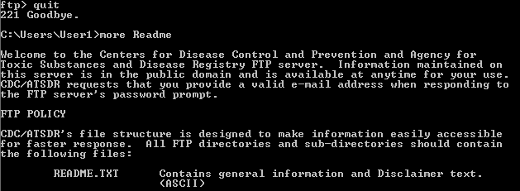
    - What is a drawback of using the FTP from the command line?
____________________________________________________________________________________

- Use FTP in a Browser
It is possible to use a browser as an anonymous FTP client.
    - In a browser, type ftp://ftp.cdc.gov/.
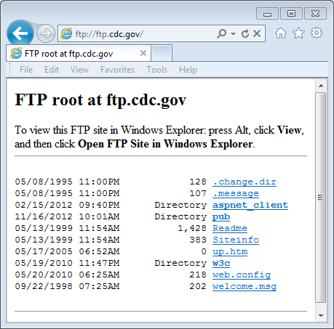
    - Click the Readme file.
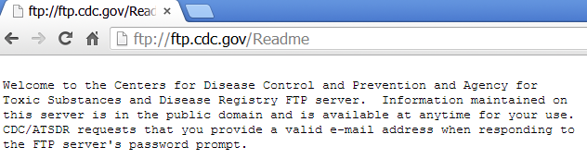
    - Close browser to disconnect the FTP connection.

- Download an FTP File Using WS_FTP LE (Optional)
In Part 3, you will download a file using WS_FTP LE (a free FTP transfer tool).
    - Start WS_FTP LE. If the Ipswitch WS_FTP LE window displays, click Next to continue and skip to step c. Otherwise, click the Open a Remote Connection link.
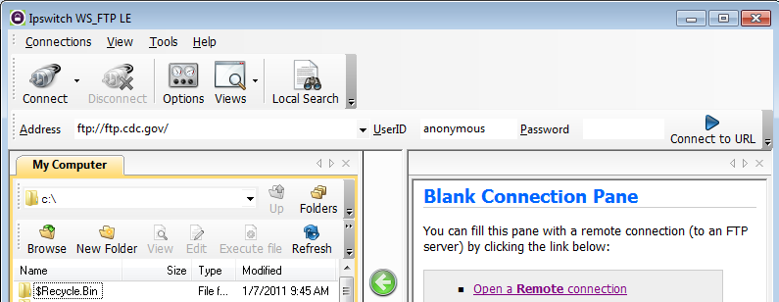
    - Click Create Site….
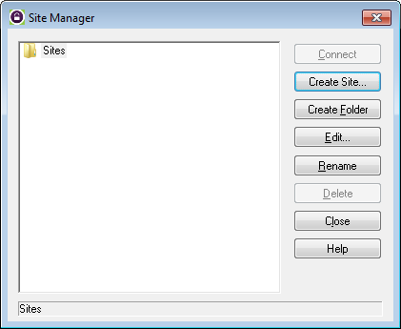

    - In the Site Name field, type Center for Disease Control and click Next to continue.
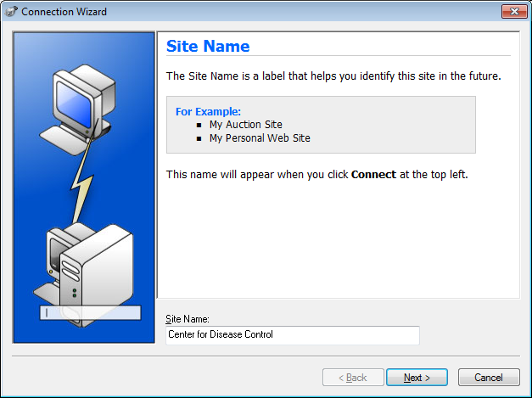
    - Click the Connection Type drop-down list, select FTP (the default connection type), and click Next.
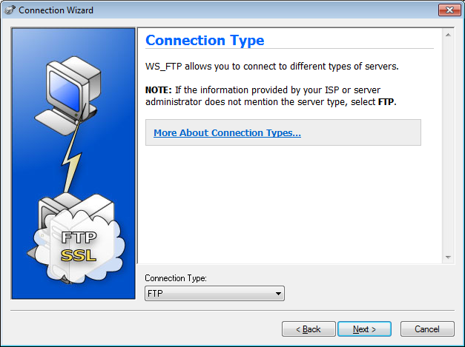
    - In the Server Address field, type ftp.cdc.gov, and click Next.
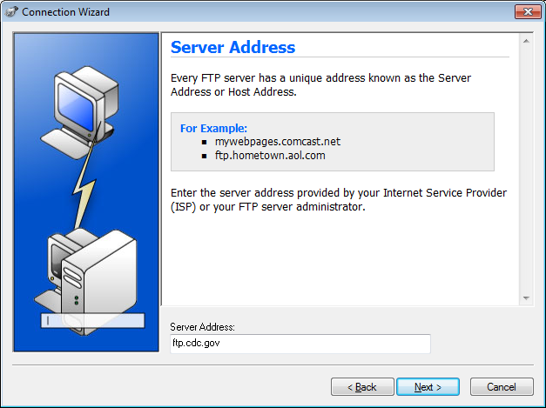
    - In the User Name field, type anonymous, and leave the password field blank. Click Next.
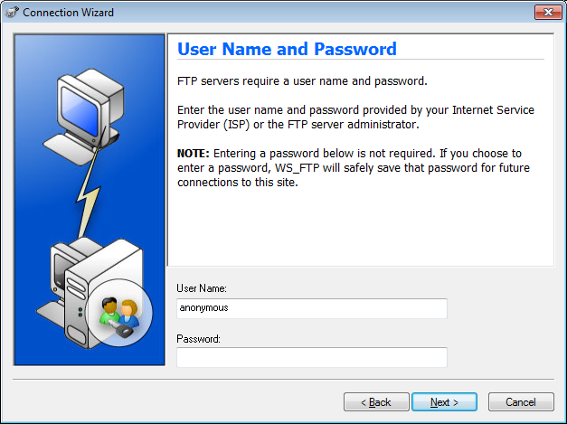
    - Click Finish.
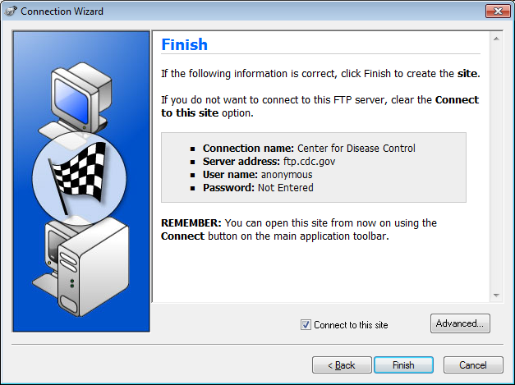
    - When the Login Information Missing dialog box displays, click OK. Do not type a password in the Password field.
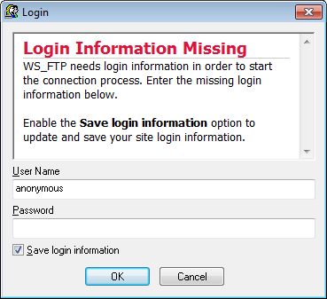

    - You are now anonymously connected to the Center for Disease Control FTP site.
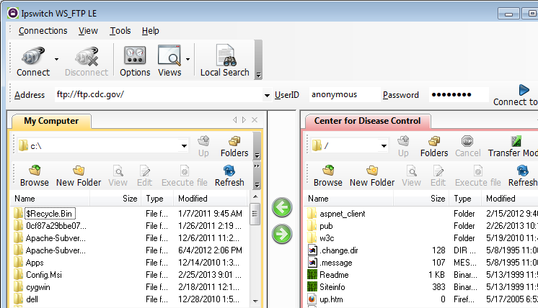
    - On the WS_FTP LE toolbar menu under My Computer, click New Folder to create a folder on your local C:\ drive.
    - In the Make Directory dialog box name the folder as CDC and click OK.
Note: If the folder already exists, you can use the same folder or create another folder with a different name. If using the same CDC folder, you can replace the existing Readme file with the downloaded Readme file.
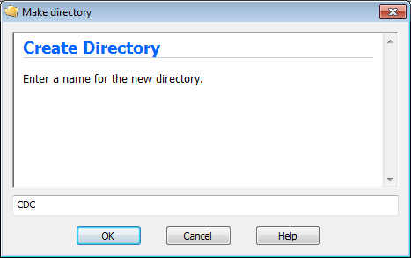

    - After the directory is created, in the My Computer tab page, double-click the directory to open it.
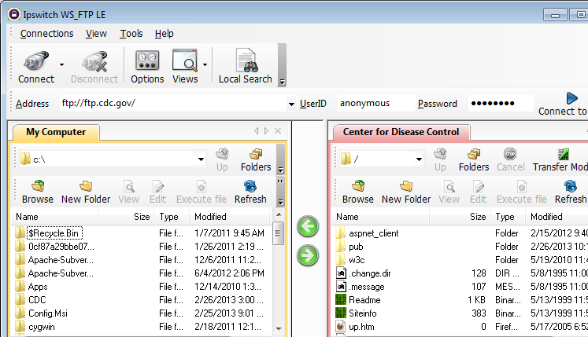
    - Drag the Readme file from the right side of the application (the remote CDC FTP server) into the CDC folder on to the local C:\ drive.
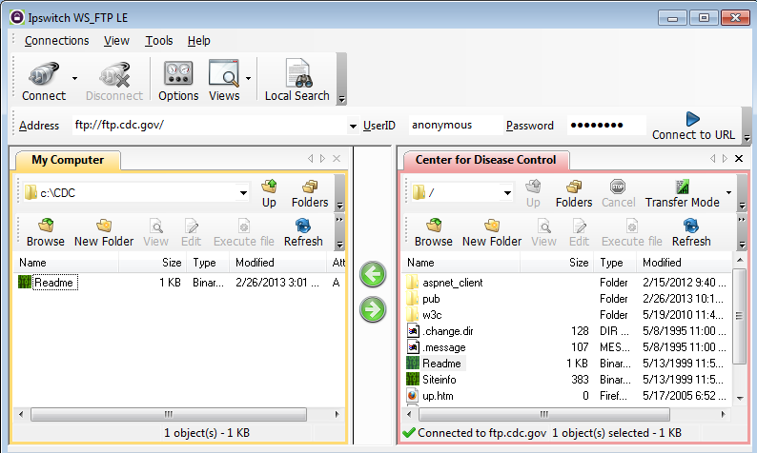

    - Double-click the Readme file in the C:\CDC folder on your local C:\ drive. If prompted for an application to open the document, choose any word processing software. You should see a message that looks something like this:
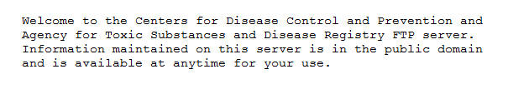
    - Which was easier, using FTP from the cmd prompt, or using WS_FTP LE? __________________
    - Verify that the Center for Disease Control window is highlighted. Click Disconnect to disconnect from the ftp.cdc.gov site when finished.
    - The remote site will be removed from the saved list of FTP sites. In the Ipswitch WS_FTP LE window, click the Open a Remote Connection link. Select the Center for Disease Control site, and click Delete to remove the FTP site. Click Yes to confirm the deletion. Click Close to exit the Site Manager.
    - Remove the C:\CDC folder.
    - Close Ipswitch WS_FTP_LE.
Reflection
List the advantages for using FTP from the command prompt, the browser, and an FTP client, such as WS_FTP LE?
_______________________________________________________________________________________
_______________________________________________________________________________________
_______________________________________________________________________________________

